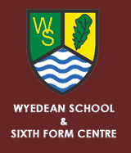

WY4 Newnham – Woolaston - Wyedean

Newnham, Outside Church | 0755
Blakeney, Kings Head | 0802
Blakeney, Opp New Road | 0803
Lydney, Outside Town Hall | 0810
Netherend, Ashway | 0817
Woolaston, Shop | 0819
Wyedean School (Arrive) | 0829

