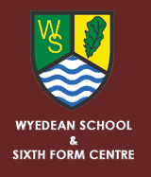

 | WY4
 | Newnham,Outside Church | 0755
 | Bullo Cross | 0758
 | Blakeney, Kings Head | 0802
 | Lydney, Outside Town Hall* | 0810*
 | Netherend, Ashway | 0817
 | Woolaston, Shop | 0819
 | Wyedean School Arrive | 0829
 | Wyedean School Depart | 1530
 | Netherend, Ashway | 1541
 | Woolaston, Shop | 1543
 | Lydney,Opp Town Hall* | 1554*
 | Blakeney, Shop | 1603**
 | Bullo Cross | 1607**
 | Newnham, Opp Church | 1609**
 | * Dean Academy School days only
 | ** Drops off on Request Only

